**21K-3200, Abdur Razzaq Siddiqui**

TASK 1-12: Submitted previously in Lab submission.

TASK 13:

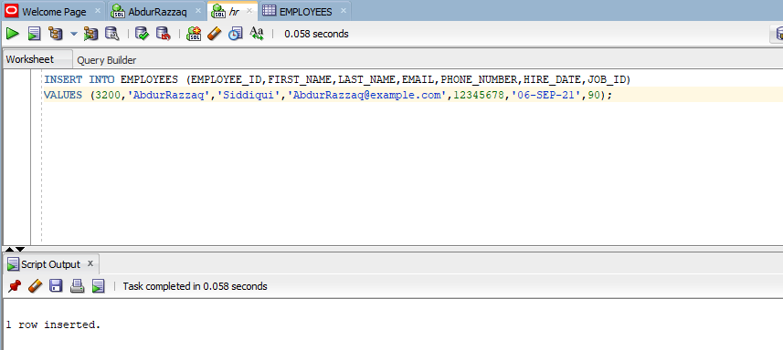

TASK 14: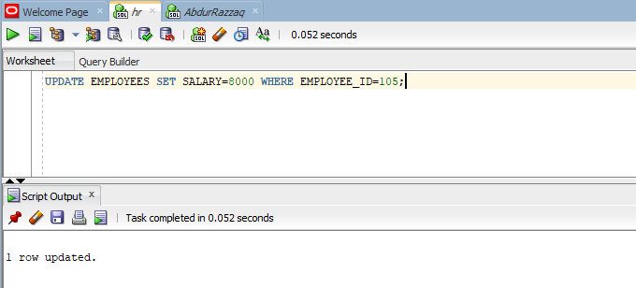

TASK 15: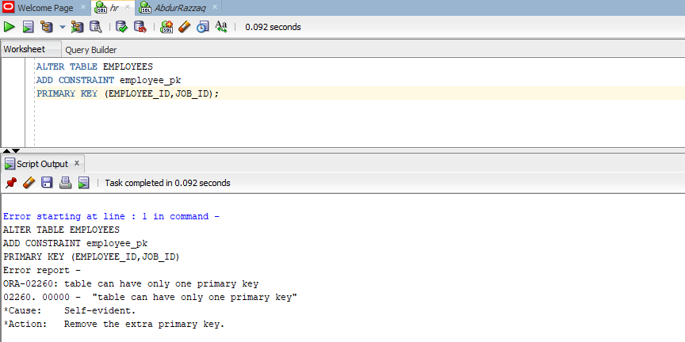

Here, the error occurred because we are trying to create another primary key. Only one primary key is allowed in a Table.

TASK 16: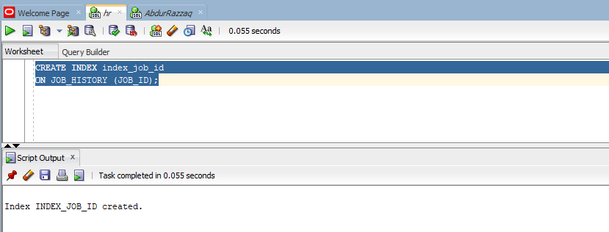

TASK 17: